Set 1
Monthly Sales Data
Dataset: Monthly Sales

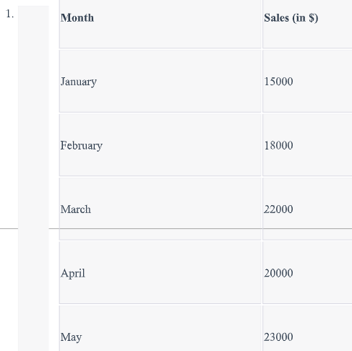1.

Create a line chart to visualize the monthly sales. Label the axes and title the chart
appropriately.
Code:
months <- factor(
c("January", "February", "March", "April", "May"),
levels = c("January", "February", "March", "April", "May")
)
sales <- c(15000, 18000, 22000, 20000, 23000)

plot(
x = 1:5,
y = sales,
type = "o",
pch = 16,
xaxt = "n",
main = "Monthly Sales Trend",
xlab = "Month",
ylab = "Sales ($)"
)
axis(
1,
at = 1:5,
labels = months
)
grid()
Output:
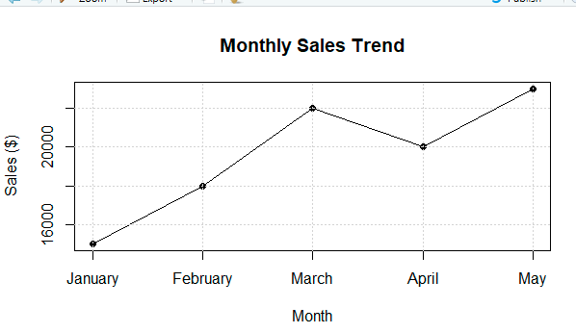
2. Generate a bar chart to display the top-selling products for the year. Label the chart elements.
Code:
products <- c("Laptop", "Mobile Phone", "Tablet", "Headphones", "Smartwatch")
product_sales <- c(45000, 38000, 27000, 22000, 18000)
barplot(
product_sales,
names.arg = products,
main = "Top-Selling Products for the Year",
xlab = "Products",
ylab = "Sales ($)",
col = "skyblue",
las = 2
)
Output:
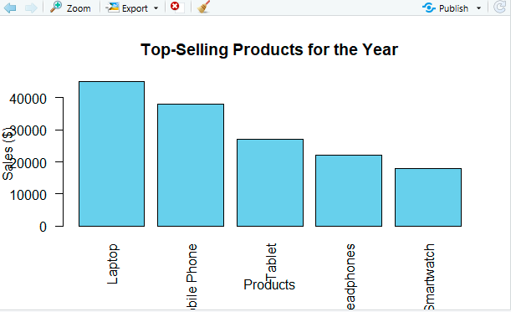
3. Develop a scatter plot to explore the relationship between advertising budget and monthly
sales. Explain the insights drawn from the scatter plot.
Code:
advertising_budget <- c(3000, 4000, 5000, 4500, 6000)
sales <- c(15000, 18000, 22000, 20000, 23000)
plot(
advertising_budget,
sales,
main = "Advertising Budget vs Monthly Sales",
xlab = "Advertising Budget ($)",
ylab = "Monthly Sales ($)",
pch = 19,
col = "red"
)
text(
advertising_budget,
sales,
labels = c("January", "February", "March", "April", "May"),
pos = 3
)
grid()
Output:
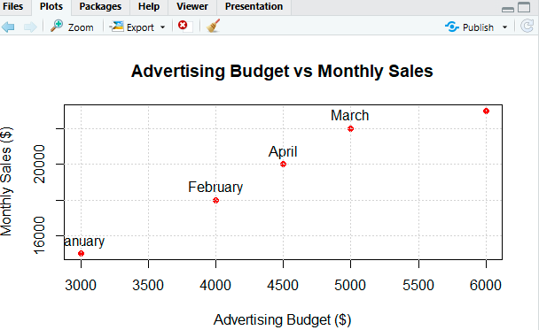
4. Build an interactive dashboard combining the line chart and bar chart to allow users to
explore sales data interactively.
Code:
library(shiny)
library(plotly)

monthly_data <- data.frame(
Month = c("January", "February", "March", "April", "May"),
Sales = c(15000, 18000, 22000, 20000, 23000)
)

product_data <- data.frame(
Product = c("Laptop", "Mobile Phone", "Tablet", "Headphones", "Smartwatch"),
Sales = c(45000, 38000, 27000, 22000, 18000)
)

ui <- fluidPage(
titlePanel("Interactive Sales Dashboard"),

sidebarLayout(
sidebarPanel(
selectInput(
"month",
"Select Month:",
choices = monthly_data$Month,
selected = "January"
)
),

mainPanel(
plotlyOutput("line_chart"),
plotlyOutput("bar_chart")
)
)
)

server <- function(input, output) {

output$line_chart <- renderPlotly({

plot_ly(
monthly_data,
x = ~Month,
y = ~Sales,
type = "scatter",
mode = "lines+markers"
) %>%
layout(
title = "Monthly Sales Trend",
xaxis = list(title = "Month"),
yaxis = list(title = "Sales ($)")
)
})

output$bar_chart <- renderPlotly({

plot_ly(
product_data,
x = ~Product,
y = ~Sales,
type = "bar",
text = ~Sales,
textposition = "auto"
) %>%
layout(
title = "Top-Selling Products",
xaxis = list(title = "Products"),
yaxis = list(title = "Sales ($)")
)
})
}

shinyApp(ui = ui, server = server)

Output:
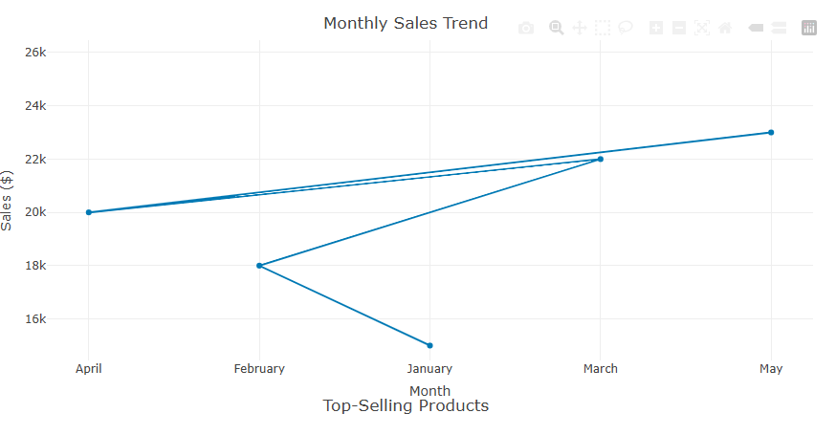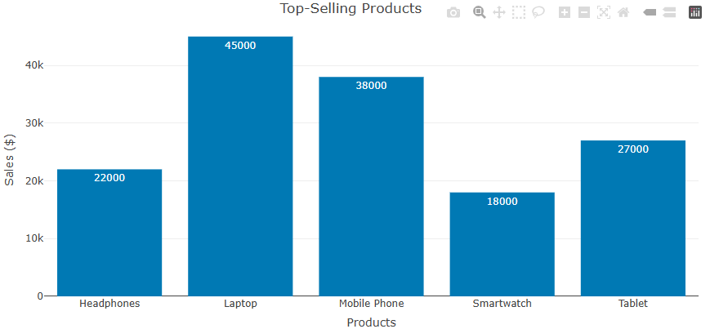
Set 2
Customer Feedback Analysis
Dataset: Customer Satisfaction

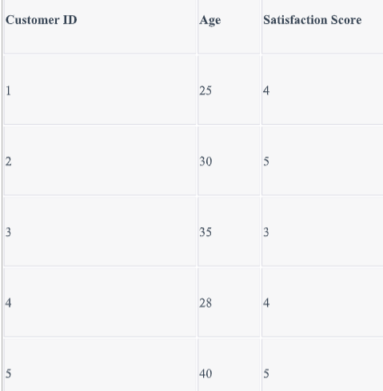
1. Create a histogram to represent the distribution of customer ages. Label the axes and title the
chart.
Code:
customer_data <- data.frame(
Customer_ID = c(1, 2, 3, 4, 5),
Age = c(25, 30, 35, 28, 40),
Satisfaction_Score = c(4, 5, 3, 4, 5)
)

print(customer_data)

hist(
customer_data$Age,
main = "Distribution of Customer Ages",
xlab = "Age",
ylab = "Number of Customers",
col = "skyblue",
border = "black"
)
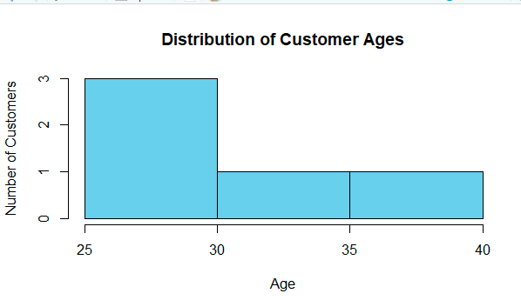
2. Generate a pie chart to display the overall distribution of customer satisfaction scores. Include
labels.
Code:
score_count <- table(customer_data$Satisfaction_Score)

labels <- paste(
names(score_count),
"Score",
"\n",
score_count,
"Customers"
)

pie(
score_count,
labels = labels,
main = "Distribution of Customer Satisfaction Scores",
col = c("lightblue", "lightgreen", "orange")
)
Output:
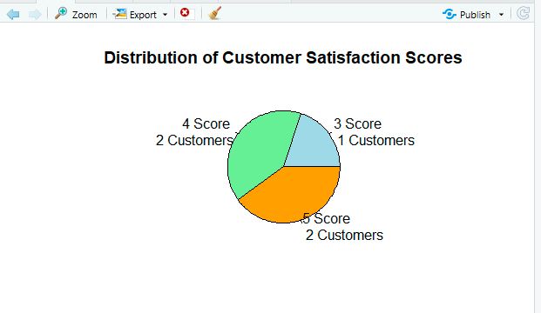

3. Build a stacked bar chart to visualize the distribution of customer satisfaction scores by age
group.
Code:
age_score_table <- table(
customer_data$Age_Group,
customer_data$Satisfaction_Score
)

barplot(
age_score_table,
main = "Customer Satisfaction by Age Group",
xlab = "Age Group",
ylab = "Number of Customers",
col = c("lightblue", "lightgreen", "orange"),
legend.text = paste("Score", rownames(age_score_table)),
beside = FALSE
)
Output:
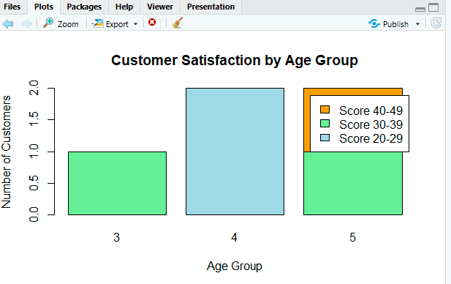
4. Develop a word cloud from open-ended customer feedback to identify prevalent customer
sentiments.
Code:
library(tm)
library(wordcloud)
library(RColorBrewer)

corpus <- Corpus(VectorSource(feedback))

corpus <- tm_map(corpus, content_transformer(tolower))
corpus <- tm_map(corpus, removePunctuation)
corpus <- tm_map(corpus, removeNumbers)
corpus <- tm_map(corpus, removeWords, stopwords("english"))
corpus <- tm_map(corpus, stripWhitespace)

dtm <- TermDocumentMatrix(corpus)

matrix_data <- as.matrix(dtm)

word_frequency <- sort(
rowSums(matrix_data),
decreasing = TRUE
)

wordcloud(
words = names(word_frequency),
freq = word_frequency,
min.freq = 1,
max.words = 100,
random.order = FALSE,
rot.per = 0.35,
colors = brewer.pal(8, "Dark2"),
main = "Customer Feedback Word Cloud"
)
Output:
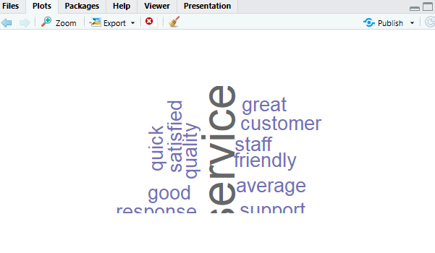

Set 3
Employee Performance Evaluation
Dataset: Employee Performance

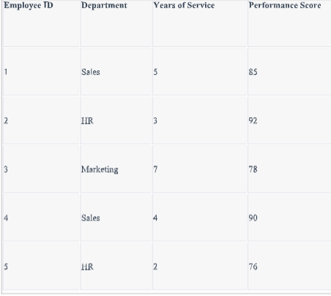
1. Create a line chart to visualize the performance trend of employees over time. Include a
legend and labels.
Code:
plot(
employee_data$Years_of_Service,
employee_data$Performance_Score,
type = "o",
pch = 16,
main = "Employee Performance Trend Over Years of Service",
xlab = "Years of Service",
ylab = "Performance Score",
col = "blue"
)
text(
employee_data$Years_of_Service,
employee_data$Performance_Score,
labels = paste("Employee", employee_data$Employee_ID),
pos = 3
)
legend(
"topright",
legend = "Performance Score",
col = "blue",
lty = 1,
pch = 16
)
grid()
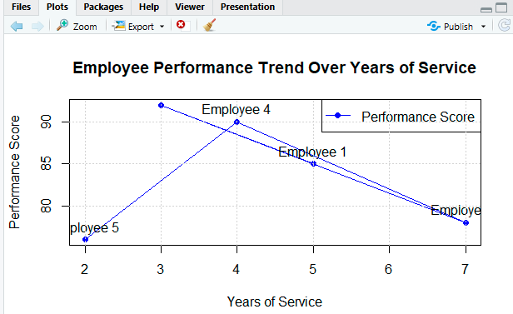
2. Generate a bar chart showing the distribution of employees across different departments.
Label the chart elements.
Code:
department_count <- table(employee_data$Department)

barplot(
department_count,
main = "Distribution of Employees Across Departments",
xlab = "Department",
ylab = "Number of Employees",
col = "lightblue",
border = "black"
)
Output:
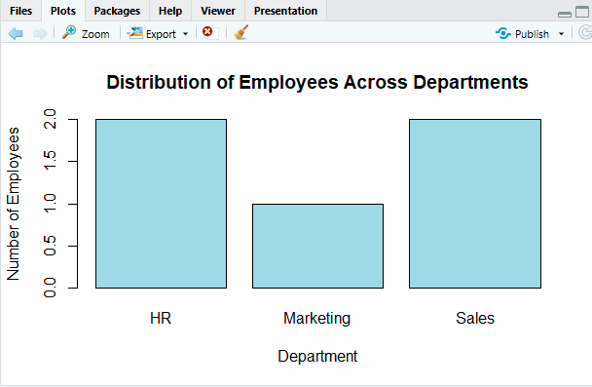
3. Build a scatter plot to analyze the correlation between years of service and performance
scores. Explain any insights.
Code:
plot(
employee_data$Years_of_Service,
employee_data$Performance_Score,
main = "Years of Service vs Performance Score",
xlab = "Years of Service",
ylab = "Performance Score",
pch = 19,
col = "red"
)

text(
employee_data$Years_of_Service,
employee_data$Performance_Score,
labels = paste("Employee", employee_data$Employee_ID),
pos = 3
)

abline(
lm(
Performance_Score ~ Years_of_Service,
data = employee_data
),
lwd = 2
)

grid()
Output:
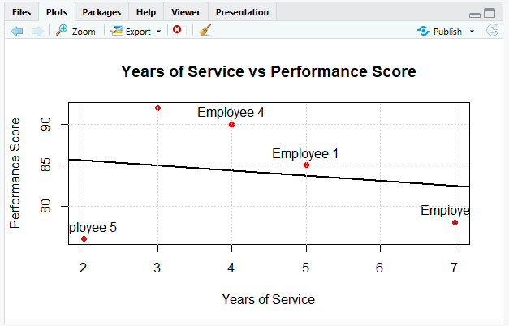
Set 4
Product Inventory Management
Dataset: Product Inventory

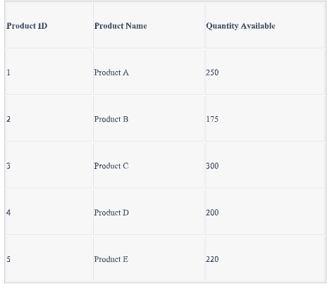
1. Create a bar chart to visualize the quantity of each product in the inventory. Label the axes
and title the chart.
Code:
barplot(
inventory_data$Quantity_Available,
names.arg = inventory_data$Product_Name,
main = "Product Inventory Quantity",
xlab = "Product",
ylab = "Quantity Available",
col = "skyblue",
border = "black"
)
Output:
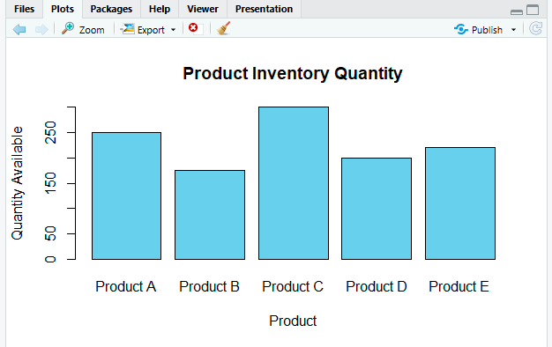
2. Generate a stacked bar chart to show the quantity of each product within different product
categories.
Code:
category_quantity <- aggregate(
Quantity_Available ~ Category + Product_Name,
data = inventory_data,
sum
)

category_table <- xtabs(
Quantity_Available ~ Category + Product_Name,
data = category_quantity
)

barplot(
category_table,
main = "Inventory Quantity by Product Category",
xlab = "Product Category",
ylab = "Quantity Available",
col = c("lightblue", "lightgreen", "orange"),
legend.text = colnames(category_table),
beside = FALSE
)
Output:
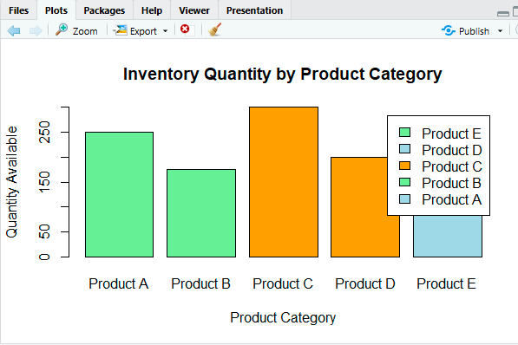

3. Build a scatter plot to explore the relationship between product price and quantity available.
Explain the findings.
Code:
plot(
inventory_data$Price,
inventory_data$Quantity_Available,
main = "Product Price vs Quantity Available",
xlab = "Product Price ($)",
ylab = "Quantity Available",
pch = 19,
col = "red"
)

text(
inventory_data$Price,
inventory_data$Quantity_Available,
labels = inventory_data$Product_Name,
pos = 3
)

abline(
lm(
Quantity_Available ~ Price,
data = inventory_data
),
lwd = 2
)

grid()
Output:
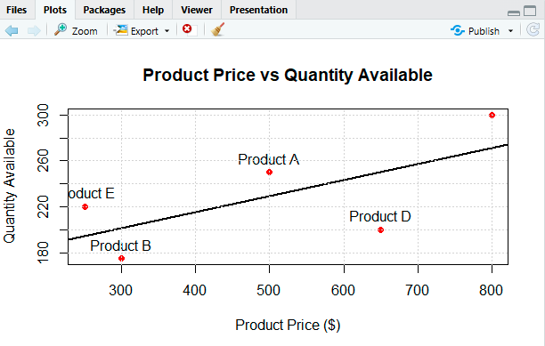

Set 5
Website Analytics
Dataset: Website Traffic

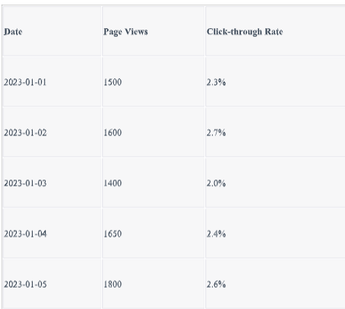
1. Create a line chart to visualize the trend in daily page views over time. Label the axes and
title the chart.
Code:
plot(
website_data$Date,
website_data$Page_Views,
type = "o",
pch = 16,
main = "Daily Website Page Views",
xlab = "Date",
ylab = "Number of Page Views",
col = "blue"
)

grid()
Output:
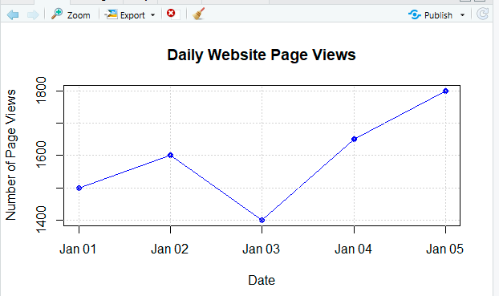
2. Generate a bar chart showing the top N days with the highest click-through rates. Label the
chart elements.
Code:
top_n <- 3

top_days <- website_data[
order(
website_data$Click_Through_Rate,
decreasing = TRUE
),
][1:top_n, ]

barplot(
top_days$Click_Through_Rate,
names.arg = format(top_days$Date, "%Y-%m-%d"),
main = "Top 3 Days by Click-Through Rate",
xlab = "Date",
ylab = "Click-Through Rate (%)",
col = "orange",
border = "black"
)

Output:
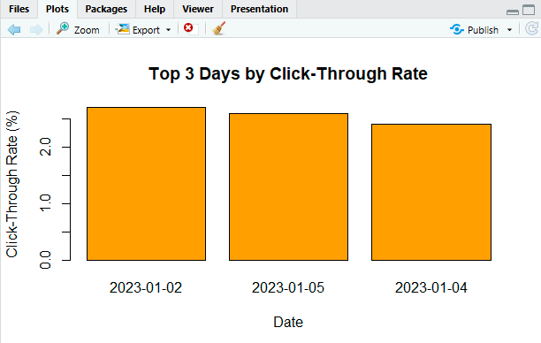
3. Develop a stacked area chart to display the distribution of user interactions (likes, shares,
comments) on a website.
Code:
interaction_data <- data.frame(
Date = as.Date(c(
"2023-01-01",
"2023-01-02",
"2023-01-03",
"2023-01-04",
"2023-01-05"
)),
Likes = c(120, 150, 130, 170, 200),
Shares = c(50, 70, 60, 80, 90),
Comments = c(30, 40, 35, 45, 55)
)

interaction_matrix <- as.matrix(
interaction_data[, c("Likes", "Shares", "Comments")]
)

matplot(
interaction_data$Date,
interaction_matrix,
type = "l",
lty = 1,
lwd = 2,
main = "Website User Interactions",
xlab = "Date",
ylab = "Number of Interactions"
)

legend(
"topleft",
legend = c("Likes", "Shares", "Comments"),
lty = 1,
lwd = 2
)

grid()
Output:
